Important dates for the Autumn Term:

Tuesday 20th September – 9am Meet the Teacher.

Monday 28th October – Friday 1st November – Half term

20th December – End of term – School closes at 1pm

How can I help at home?

- Please encourage your child to use Numbots and My Maths
- All children should be reading regularly to an adult. Please write a comment the reading record if your child has read.
- Please ensure your child reads a variety of fiction and non-fiction texts, and records these in their Reading Records.
- Please ensure that your child comes in their PE kit on Wednesdays and Fridays.
- A homework grid, with instructions, will be issued. The children are expected to complete 3 tasks from the options and hand in either in person or on Google Classrooms.

St Alban & St Stephen Catholic Primary School & Nursery

Year 1 Parent Information Booklet
Learning and Growing with God by our side
What your child will be learning about this term and how you can help at home
Autumn Term 2024



RE | Holidays/Holydays: children will investigate Pentecost: celebrating the new life the Spirit brings.  Building Bridges: exploring how important it is to work at friendships and admit wrong.  Difference: children will explore how differences bring richness and variety to life.
English
We start the term with The Tiger who came to Tea. We will be looking closely at how to build up sentences, bossy words and writing a recount.
We will then be reading Here comes Mr. Postmouse. This will teach children the structure of letter writing.

HOW YOU CAN HELP
Practise reading and spelling the tricky words that they bring home (after October half term). Encourage children to read for 10 minutes per day. Children can also use www.phonicsplay.com and the Alphablocks series on BBC I player.

Maths
We will be learning to use positional and ordinal language (e.g. first, second, third). We will be learning to ‘Subitise’ numbers which means recognising patterns of how many there are without needing to count. We will be comparing numbers using the vocabulary more and fewer. We will also be learning to find 1 more and 1 less than numbers to 20. We will be learning to split up numbers in different ways and to use a part-whole model. We will learn to add and subtract numbers using practical resources and mental strategies. We will learn to name and describe common 2d and 3d shapes.
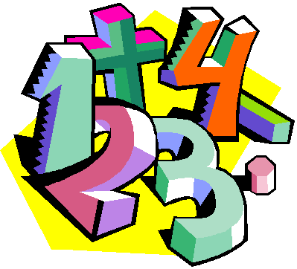
HOW YOU CAN HELP:
Children can use ‘Numbots’ to learn about number bonds to 20. Play board games to develop a range of mathematical skills.

R.E.
Family - We will learn that God loves every family and we will listen to the Creation story.
Belonging – We will learn that Catholic’s are welcomed into God’s family through the Sacrament of Baptism and about what happens at a Baptism.
Waiting – We will learn that Advent is a time when we prepare for Christmas and will listen to and retell the Nativity story.
Judaism- We will find out about some of the ways that Jewish people worship. We will also learn about the Biblical characters of Abraham and Moses.


Geography
For the first half of the term, our topic will be a Geography based one, where we find out all about where we live, our road, our town, our country, our planet! We will then look more closely at our local area. We will go for walks in our school grounds and local area and create simple maps. We’ll also learn how to write our own address.

History
After half term, we will be learning about transport and the changes that have occurred in the past 100 years. We will explore journeys of all kinds and look at how people used to travel around and how we travel now. We will compare the first plane flight with todays.

Art
This term, we will look at artists such as Hannah Sessions who is a local artist from Saint Albans. We will be exploring line and colour.

We will also look closely at the seasons and use wax resist technique to create stunning autumnal pictures

Science
In our science topic this term, we will learn about the basic parts of the human body and explore our five senses using a wide range of exciting activities.
After half term, we will look closely at the season of autumn and the changes that occur outside. We will also investigate common and wild garden plants and materials.

PE
We will be working on our running. We will be learning a dance based on the theme of growing. We will be focusing on body parts in gymnastics.
Music
We will play instruments to a steady beat, with control. We will begin to create simple rhythmic patterns and begin to identify crotchets and quavers. After half term, we will be learning songs for our Christmas play.
Computing
The children will learn to login and navigate around a computer, developing mouse skills, learning how to drag and drop, click and control a cursor. They will be using painting programs and using the keyboard to type words or captions. They will also begin to program the BeeBot Robots.

